Registration for the 2026 Ligonier, PA Highland Games
(Please return this form with your payment by April 30, 2026 to guarantee a T-Shirt)
Full Name:____________________________________________________________________________________________
Address:______________________________________________________________________________________________
Phone Number:_____________________________________________________________________________________
E-mail Address: _____________________________________________________________________________________
Clan Galbraith Society Members and immediate family $59.95 each or $20.00 each for children 12 and under.
Number Attending Adult__________Number Attending 12 and Under_______________
Non-Member attending $109.95 each or $20.00 each for children 12 and Under
Number Attending Adult___________Number Attending 12 and Under_____________
Please mark your size and quantity of shirts desired with a number.
Youth Sizes Youth Sizes Adult Unisex Sizes Adult Unisex Sizes
(Heather Navy): (Heather Forest): (Heather Navy) (Heather Forest)

Small____________ Small___________ X-Small____________ X-Small___________
Medium_________ Medium________ Small______________ Small_____________
Large____________ Large___________ Medium___________ Medium__________
XL_______________ XL_______________ Large______________ Large_____________
XL__________________ XL_________________
2XL________________ 2XL_______________
3XL________________ 3XL_______________
4XL________________ 4XL_______________
Heather Navy Heather Forest
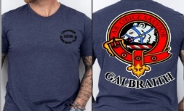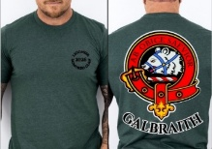
Please return this registration form and check to:
Paul Galbraith, 336 Pleasant Plains Rd, Jackson, Tennessee 38305 (USA)
or
Register Online on our Website

